**Project Details**

|  |  |
| --- | --- |
| **Project Code:** |  |
| **Project Name:** | OneGP - Budget Planning |
| **Account:** | GrameenPhone |
| **Location:** | Bangladesh |
| **Customer Name:** | GrameenPhone |
| **Delivery Head/ Email ID:** |  |
| **Program Manager / Email ID:** |  |
| **Quality Coordinator / Email ID:** |  |
| **Customer Contact Information:** |  |
|  |
| Basundhara, Dhaka, Bangladesh |

|  |  |  |  |  |
| --- | --- | --- | --- | --- |
| Mohammad Al-Nur Sarwer Arif, 27/09/2022 |  |  |  |  |
| **Prepared by/Date** |  | **Reviewed by/Date** |  | **Approved by/Date** |

**Revision History**

|  |  |  |  |  |  |
| --- | --- | --- | --- | --- | --- |
| **Version (x.yy)** | **Date of Revision** | **Description of Change** | **Reason for Change** | **Affected Sections** | **Approved By** |
|  |  |  |  |  |  |
|  |  |  |  |  |  |
|  |  |  |  |  |  |
|  |  |  |  |  |  |
|  |  |  |  |  |  |
|  |  |  |  |  |  |
|  |  |  |  |  |  |
|  |  |  |  |  |  |

**List of Reference Documents**

|  |  |
| --- | --- |
| **Name** | **Version No.** |
|  |  |
|  |  |
|  |  |
|  |  |

## ***Introduction***

This module is a new module of OneGP. The name of the module is Budget Planning. From the OneGP application, employees of technology can raise budget plan requests providing the information of year, budget head, amount(BDT), amount(USD), project name and stakeholder lead. Employees can also upload budget request data in bulk. After the application is submitted successfully, employees or forum members will be able to see the request. Employees can add forum members by submitting their name and section. Forum members will edit budget requisition and will set budget code for each budget head, which is called budget lock and all history will be captured. After budget lock employee will plan date wise ordering and will edit budget requisition and all history will be captured. After budget lock employee will plan date wise capitalization and will edit capitalization plan and all history will be captured. Employees can raise purchase request (PR) providing the information of PR number, PR date, PO number, PO issue date, amount(BDT), amount (USD), PR description, tentative capitalization date. PR amount should not exceed remaining budget amount. Employees can raise capitalization by providing the information of the respective PO number, capitalization amount, date, Coupa/SRT reference. Capitalization amount should not exceed remaining PO amount. Employees or forum users can carry forward any amount from previous year.

## ***Scope***

1. Master Data Management
   1. Budget Requests
      1. Admin can view budget request related information.
      2. Admin can search budget request related information by the name of an employee, section, year.
2. Budget Plan Requests
   1. Budget Requests
      1. Employee can add/edit budget plan request.
      2. To raise a request for new budget request, an employee should provide the information of year, budget head, amount(BDT), amount(USD), project name and stakeholder lead.
      3. Employee can transfer budget plan request.
      4. Employee can drop budget plan request.
      5. After the application is submitted successfully, employees or forum members will be able to see the request.
      6. Employees can search budget request related information by the name of an employee, section, year.
   2. Bulk Request
      1. Employees can also upload budget request data in bulk.
   3. Carry Forward
      1. Employees or forum users can carry forward any amount from previous year.
3. Forum Members
   * 1. Employees can add forum members by submitting their name and section.
4. Budget Lock
   * 1. Forum members will edit budget requisition and will set budget code for each budget head, which is called budget lock and all history will be captured.
     2. After budget lock employee will plan date wise ordering and will edit budget requisition and all history will be captured.
     3. After budget lock employee will plan date wise capitalization and will edit capitalization plan and all history will be captured.
5. Purchase Request (PR)
   * 1. Employees can raise purchase request (PR) providing the information of PR number, PR date, PO number, PO issue date, amount(BDT), amount (USD), PR description, tentative capitalization date.
     2. PR amount should not exceed remaining budget amount.
6. Capitalization
   * 1. Employees can raise capitalization by providing the information of the respective PO number, capitalization amount, date, Coupa/SRT reference. Capitalization amount should not exceed remaining PO amount.
     2. Bulk capitalization upload for forum members (excel).

## **Design Description**

3.1 **Business Process Design**

Below figure: 01 represents the whole business process of Budget Planning.

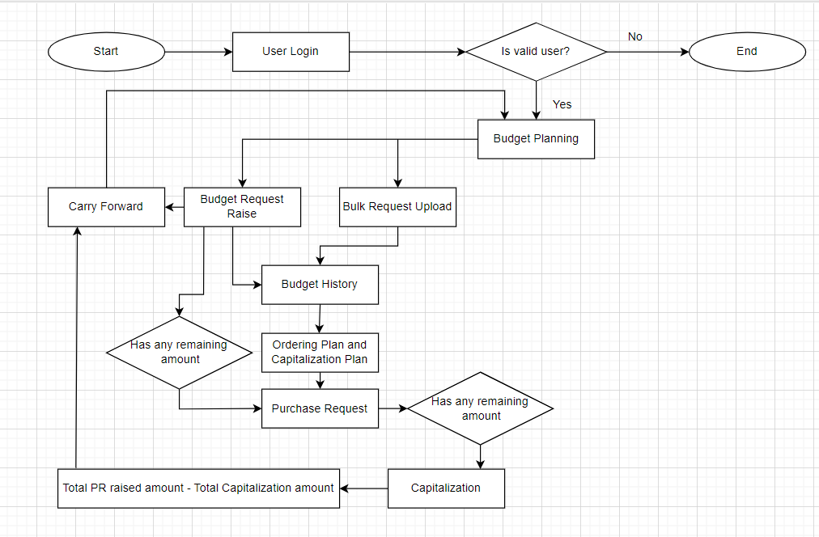

**Figure 01: Business process of Budget Planning**

**3.3 Unified Model Diagram**

**3.3.1 USE CASE Diagram for Budget Planning**

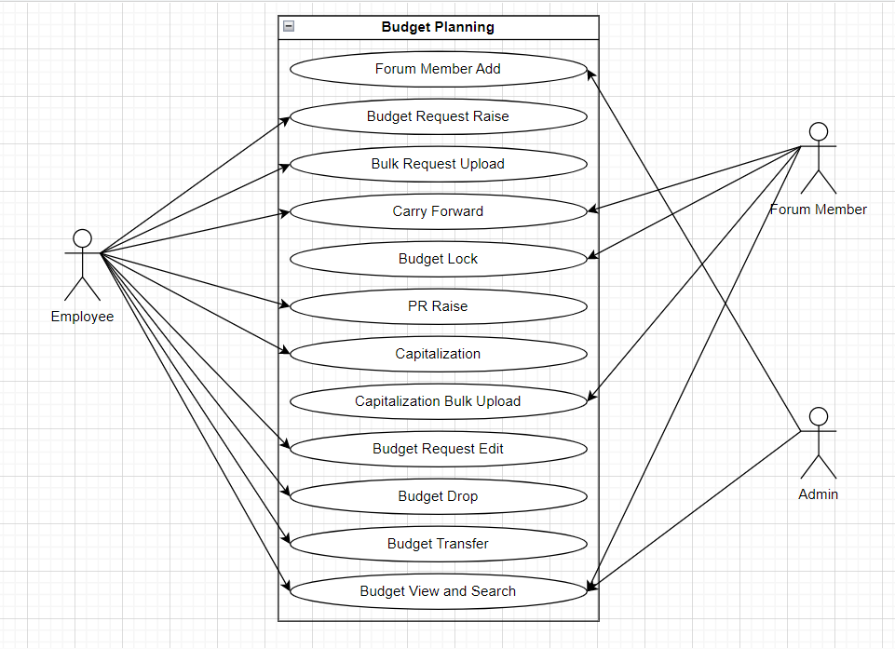

**Figure 3.3.2: Use Case Diagram**

**3.3.2 Sequence Diagram**

**3.3.2.1 Sequence diagram for Budget Planning**

**Figure 3.3.3: Sequence diagram for Budget Planning**

**3.4 Prototype Design**

**3.4.1 Budget Plan**

For this module, the Employee can raise a budget plan request. Employee can also upload budget in bulk. Employee can carry forward the extra amount for future budget.

**3.4.1.1 Process Flow**

**Web:**

**Budget Requests:**

* 1. Login to OneGP web application
  2. Employees can request a budget plan from Budget Requests -> New Request.
  3. Employees can upload in bulk from Budget Requests -> Bulk Upload.
  4. Employees can carry forward amount from Budget Requests -> Carry Forward.

**3.4.1.1.1 DB Operation**

|  |  |
| --- | --- |
| **Table Name** | **Change Type** |
|  |  |

**Ordering Plan and Capitalization Plan:**

* 1. Login to OneGP web application
  2. After budget lock employee will plan date wise ordering and will edit budget requisition and for that the employee needs to go to Budget Requests and then go to Ordering Plan.
  3. After budget lock employee will plan date wise capitalization and will edit capitalization plan and for that the employee needs to go to Budget Requests and then go to Capitalization Plan.

**3.4.1.1.2 DB Operation**

|  |  |
| --- | --- |
| **Table Name** | **Change Type** |
|  |  |

**Purchase Request:**

* 1. Login to OneGP web application
  2. If there is any budget amount remaining then employee can raise Purchase Request and for that the employee needs to go to Budget Requests and then go to PR.

**3.4.1.1.3 DB Operation**

|  |  |
| --- | --- |
| **Table Name** | **Change Type** |
|  |  |

**Capitalization:**

* 1. Login to OneGP web application
  2. If there is any PR amount remaining then employee can raise capitalization and for that the employee needs to go to Budget Requests and then go to CP.

**3.4.1.1.4 DB Operation**

|  |  |
| --- | --- |
| **Table Name** | **Change Type** |
|  |  |